◆ Platform User Guide — Internal Evaluation Follow-up Team ◆
For: two members of the central administration — their scope is the whole system
Your scope is the whole system: both sectors, the complexes and the schools. You make sure no lesson is left without an observer, and you observe too: each of you has an independent form with its own score and name. The adopted score for a lesson is the average of those who scored it.
Before you start — four things that concern everyone
1. Open the link — https://ahseyam.github.io/unified-lesson/
2. Switch to English — the EN button, top right
3. Choose your role — one card per role
4. Enter your staff number — you are identified by it, not by your name

• Open the link: It runs on phone, laptop and tablet with nothing to install. Bookmark it — it is your single reference; do not rely on a copy someone sends you, or you will be working from yesterday's data.
• Switch to English: Press it once and the choice is remembered on your device. Arabic is the default for everyone, so nothing changes for your Arabic-speaking colleagues. You may enter your own text in English or Arabic — both are kept as typed.
• Choose your role: Each role sees only what concerns it: its own buttons, screens and reports. You will not see what is not yours, and you cannot press a button that destroys someone else's work.
• Enter your staff number: Names repeat and are spelled in different ways, so the same person appears twice in the reports. If your number is on the roster, your name and subject are filled in for you.
❖ Step by step — with pictures every screenshot is taken from the platform itself, not drawn or imagined
1 Sign in with your role
• Choose the “Internal evaluation follow-up team” card — it is the last of them.
• You are asked for neither a subject nor a complex: your scope is the whole system.
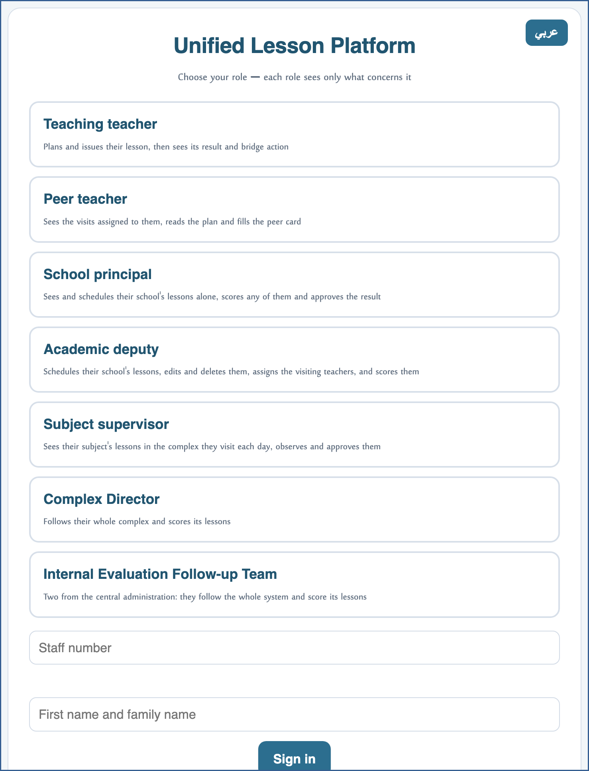
A live screenshot of the platform itself
2 Read the schedule
• You see every lesson in the system: both sectors, the complexes and the schools.
• No cell is edited — following up is reading, not writing.
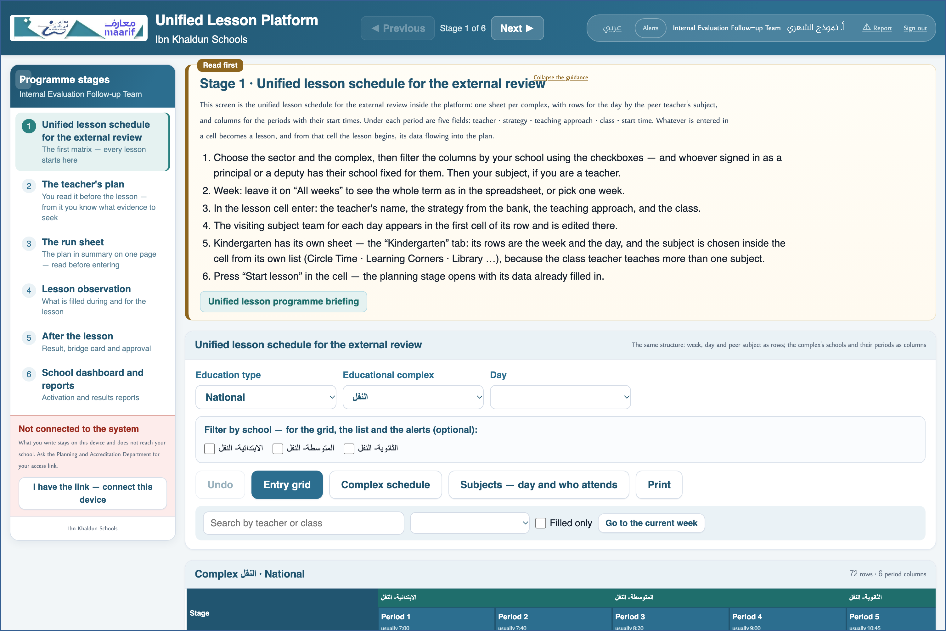
A live screenshot of the platform itself
3 Follow what has no supervisor
• The “Lessons with no subject supervisor” report is your first task: who observes them, and whether they have been observed.
• If one remains with no observer, you alert the deputy or the complex manager.
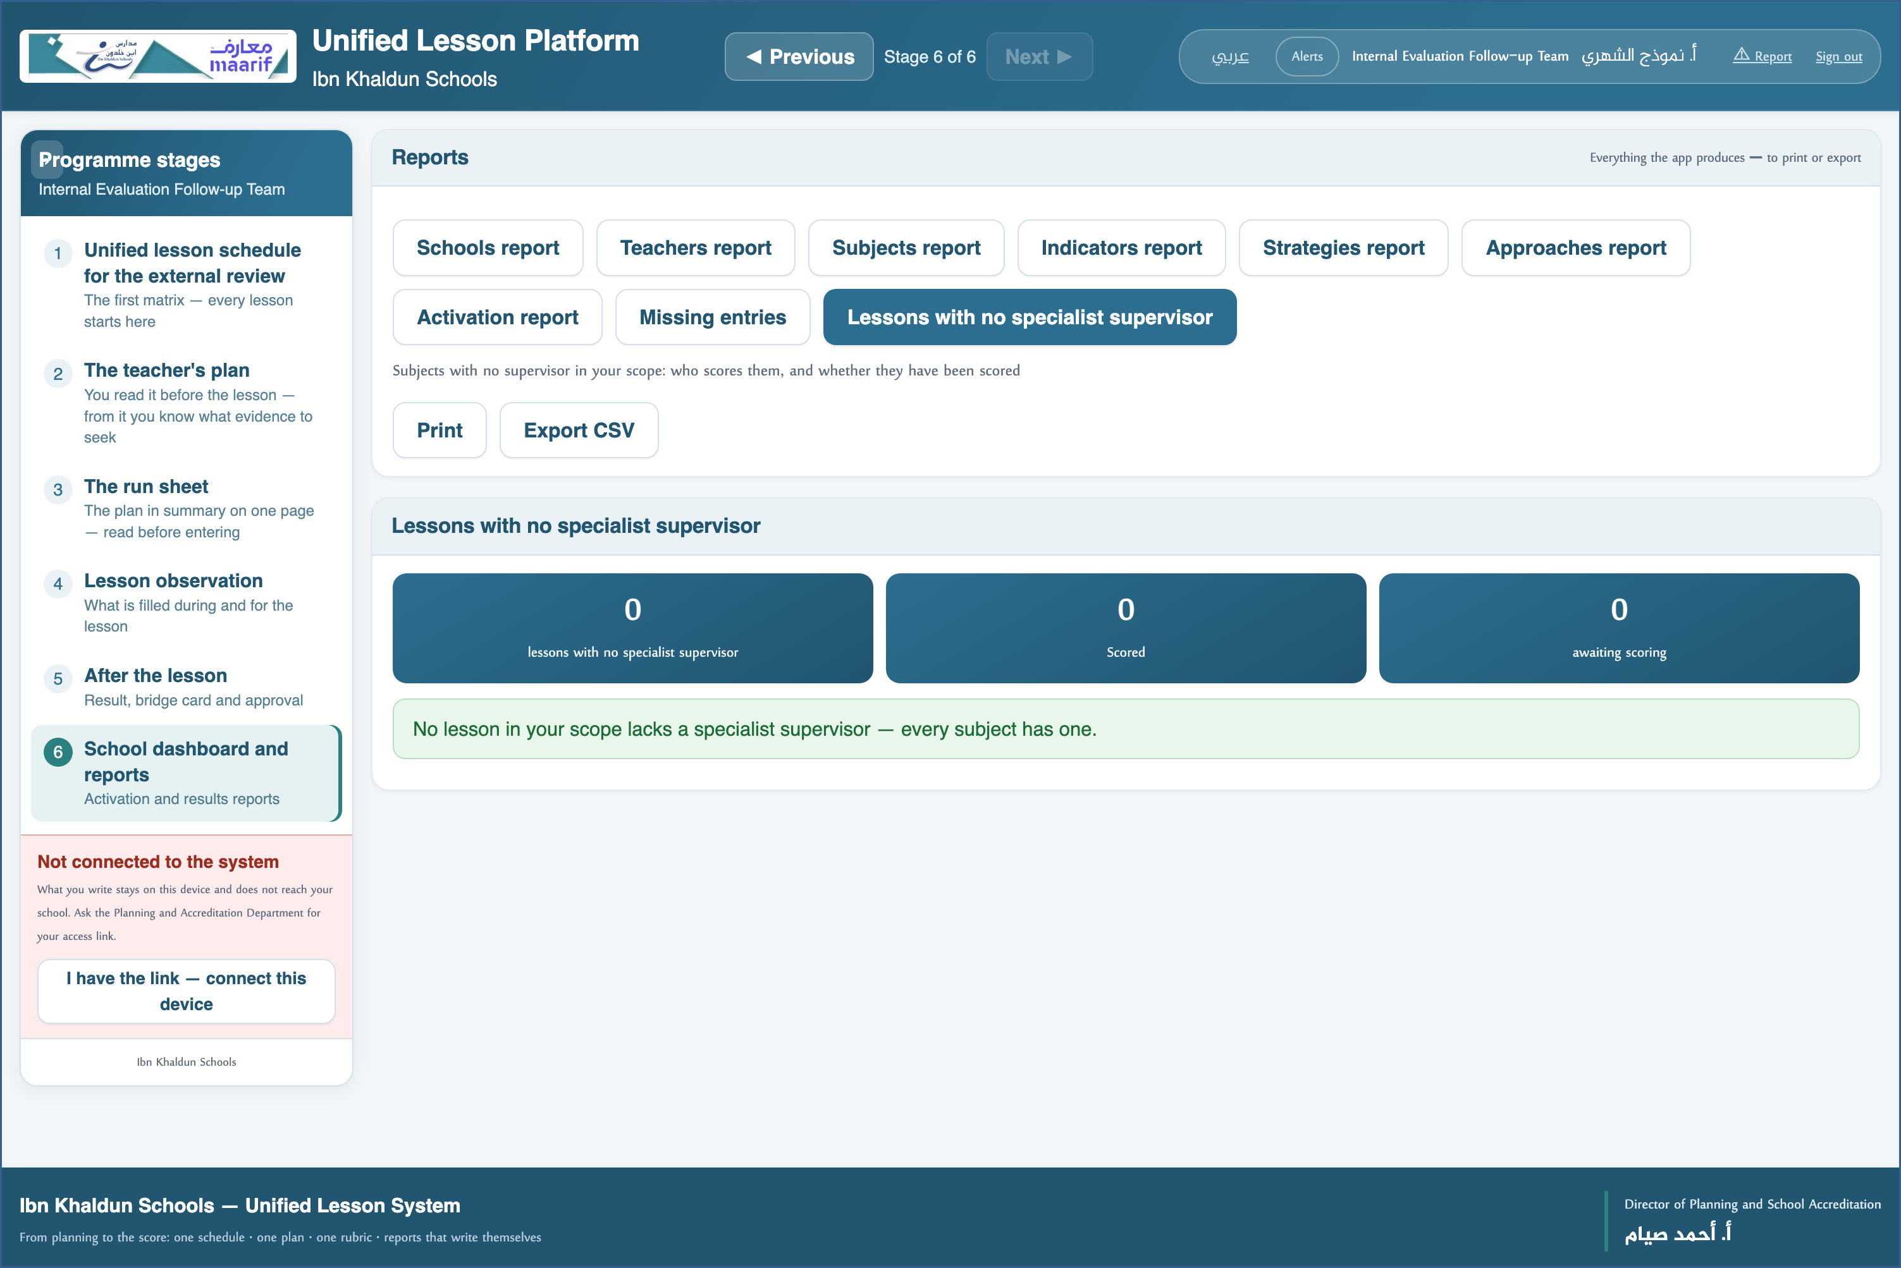
A live screenshot of the platform itself
4 Observe the lesson
• Open the lesson under “Lesson observation”; your capacity is filled in from your role.
• Fill the form and the strategy card — each of you has their own form.
⛔ Your form carries your name, and no other observer overwrites it — their score appears beside yours.

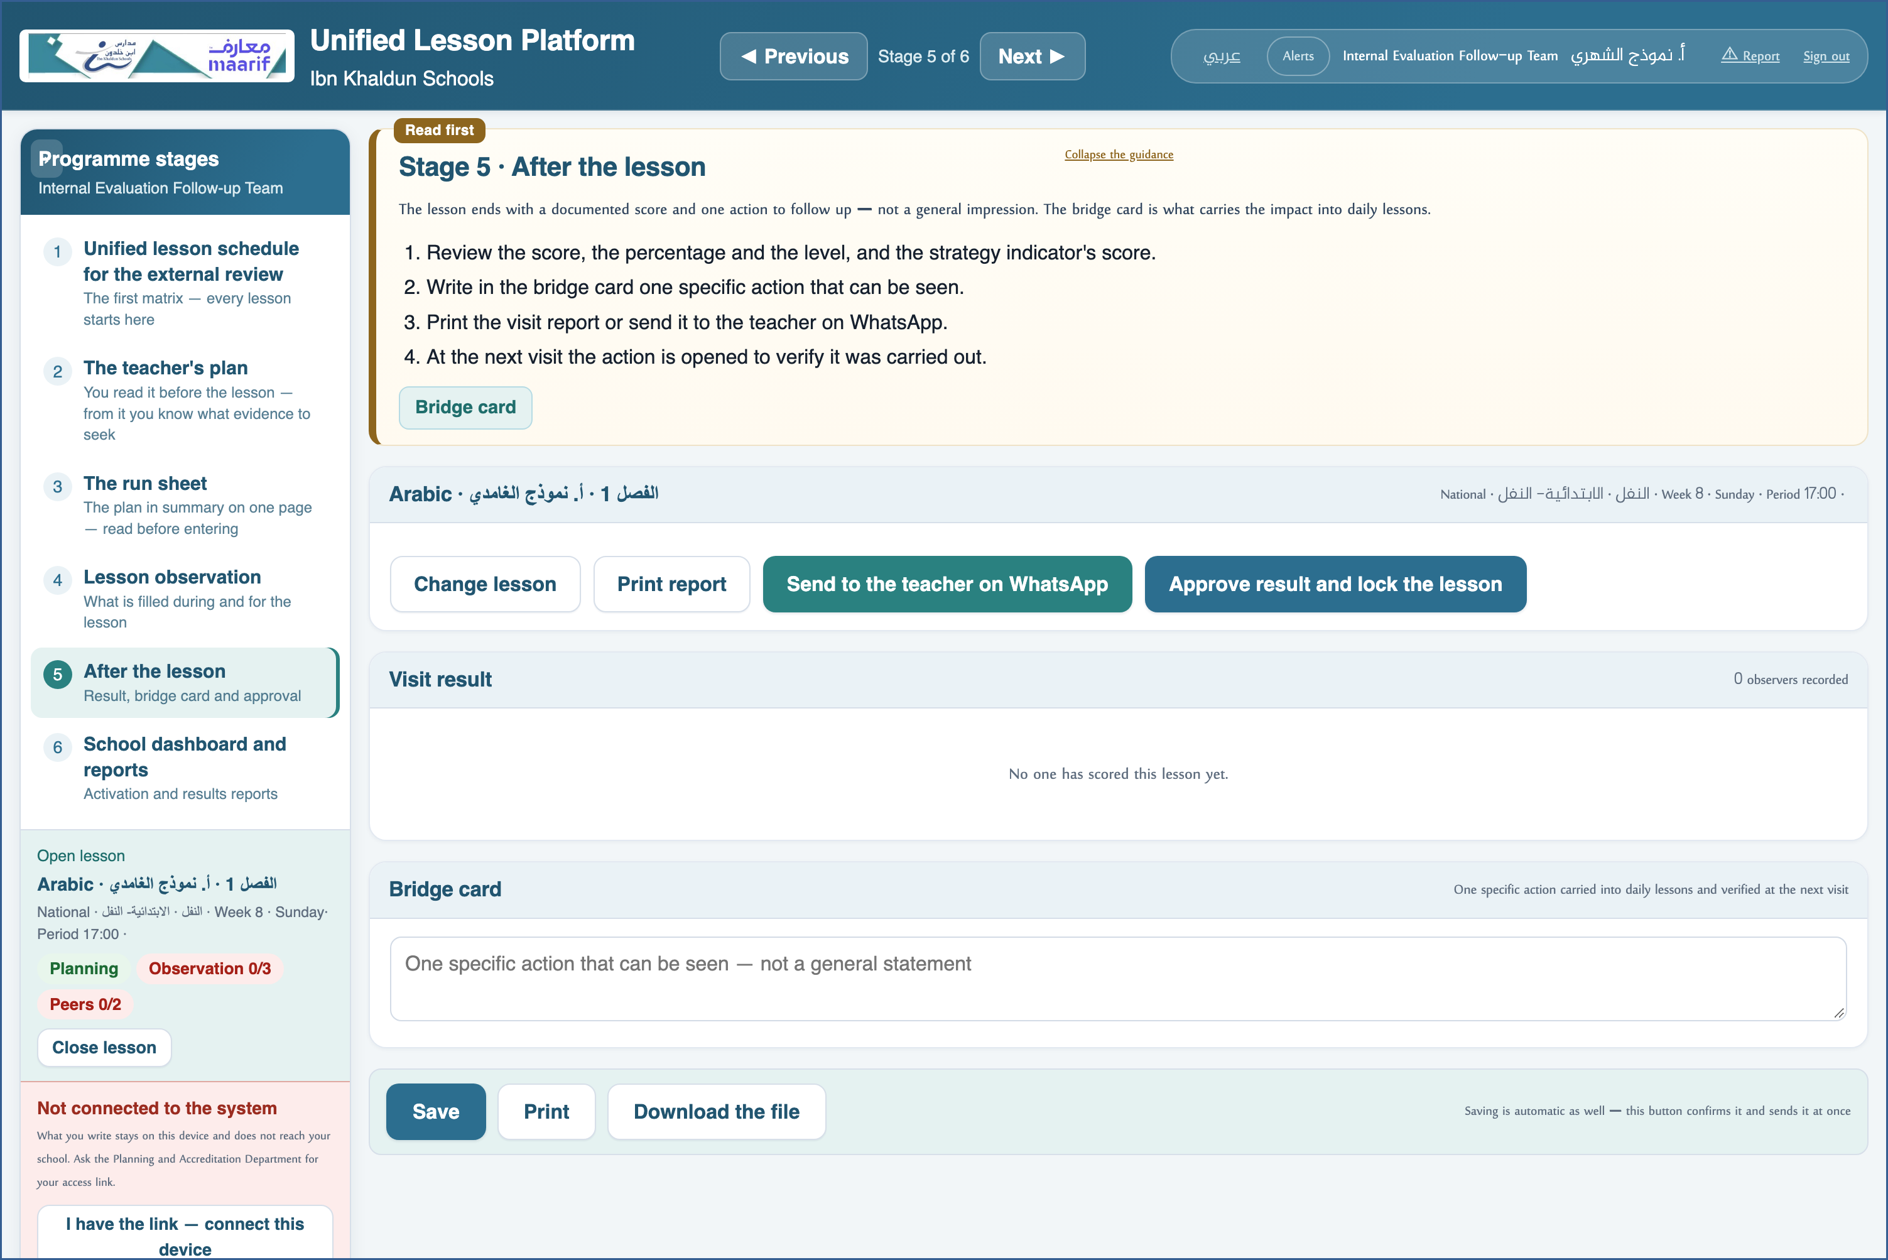
A live screenshot of the platform itself
❖ Where things usually go wrong before you ask — the most common cases
What happens | Why, and what to do
Where is the form? | Under “Lesson observation” once the lesson is open — and a bar at its head moves you between the teacher's prep, the form and the strategy card.
I see every lesson in the system — is that right? | Yes: your scope is the whole system, unlike the complex manager who is confined to theirs.

❖ Frequently asked
Q: Does our score count towards the lesson average?
A: Yes — the adopted score is the average of everyone who scored, so yours is part of it.
Q: How do we know what is late?
A: The “Missing entries” report measures the schedule against the teacher roster and names whoever has not registered yet.
Who to contact
If what concerns you does not appear, or something that is not yours does — contact the Planning and School Accreditation Department.
If the page does not open at all — check the link above and your connection.

https://ahseyam.github.io/unified-lesson/
Planning and School Accreditation Department · Ahmed Seyam

